Data Technician Workbook
Week 1: Excel

Name:
Course Date:
Table of contents
Day 1: Task 1 2
Day 2: Task 1 2
Day 2: Task 2 3
Day 2: Task 3 4
Day 3: Task 1 4
Day 3: Task 2 5
Dataset: 5
Step 1: Create a Pivot Table 5
Step 2: Use the SWITCH Function 5
Submission: 6
Day 3: Task 3 6
Day 4: Task 1 7
Course Notes 9
Additional Information 10

Day 1: Task 1

Please research and complete the boxes below on common laws and regulations that must be followed when working with customers' data, and use the below bulleted list to support your answers.

- What is it
- Why is it important
- Provide a real-world example of how you can follow it
- How does it impact working with data
- What could happen if you breached it

Data Protection Act | What is it?  The Data Protection Act (2018) is a piece of legislation produced with the purpose of protecting data and personal information. The act provides sticked, standardised principles for working with data to preserve confidentiality, integrity and availability for authorised users.  Why is it important?  The Data Protection Act (2018) is a crucial piece of legislation because it ensures data accessed and used is lawful and fair. Businesses and organisations, like the NHS, have strict regulations for handling and managing data. The implementation of this act promotes accountability and preserve data integrity and cyber attacks.  Real world example  Within organisations like the NHS, alongside the Data Protection Act (2018) they will have a data protection policy. As a result of the data held by the NHS, strict governance is required when dealing with sensitive data. Across the organisation, data will be limited, to prevent unnecessary or unfair unauthorised access. Policy of least privilege will be implemented to ensure only required staff access specific data, such as medical history.  How does it impact working with data?  The Data Protect Act (2018) has a significant impact on working with data. Within organisations, employees have a duty to uphold data protection laws when working with personal or sensitive information. In relation to the role of a data analyst, there is a direct correlation because the role is collecting, processing and sharing data. Therefore adhering to organisational policy and British law as a data analysis ensures data is handled ethically and securely.  What could happen if you breach it?  If a breach of the data protection act occurs when working with data, it must be acted upon as soon as the breach is identified. If a breach of the act occurs, the organisation will suffer financial and reputational damage. The Information Commission Office can enforce warning and financial penalties.  https://www.legislation.gov.uk/ukpga/2018/12/contents/enacted  https://www.england.nhs.uk/long-read/data-protection-policy/  https://ico.org.uk/for-organisations/uk-gdpr-guidance-and-resources/data-sharing/data-sharing-a-code-of-practice/enforcement-of-this-code/  https://www.datadrivenlegal.com/blog/can-individuals-be-held-responsible-for-data-breaches-uk-gdpr
GDPR | What is it?  The UK General Data Protection Regulation is derived from the General Data Protection Regulation that is used in Europe. The regulation imposes strict requirements to organisation handling and working with data. The regulation works in hand with the Data Protection Act (2018), to maintain confidentiality of data.  Why is it important?  The General Data Protection Regulation is important because it governs organisations working with data. Alongside maintaining compliance, it is essential for maintaining reputation alongside sensitive data.  Real World Example  One real world example of GDPR being compromised happened to British Airways in 2018. The organisation had a data breach, impacting more than 400,000 customers. This was investigated by the ICO and £20 million financial for failure to maintain data integrity and confidentiality.  How does it impact working with data?  GDPR impacts working with data, particularly as a data analyst. This is because GDPR enforces regulations to ensure data is handled in compliance with the data protection legislations. As a requirement minimal personal data should be collected and used, alongside implementing security methods such as encrypted passwords to prevent unauthorized access or adaptations.  What could happen if you breach it?  GDPR breaches have negative implications on an organisation. The ICO will conduct audits and investigations on the organisation and implement penalties or sanctions. If there is a breach due this may lead to reputational damage including loss of trust and potential claims.  https://www.legislation.gov.uk/eur/2016/679/contents  https://gdpr.eu/what-is-gdpr/  https://www.gdprregister.eu/articles/british-airways-fine/?utm_source  https://www.nibusinessinfo.co.uk/content/gdpr-penalties-and-fines
Freedom of Information Act | What is it?  The Freedom of Information Act (2000) enables access to information retained by public authorities, including the NHS and local authorities. If a request for information is made, it must be responded to within 20 working days. However this act generally does not cover small businesses and charities or organisations with exemptions.  Why is it important?  The Freedom of Information Act (2000) is important because it promotes accountability and transparency with the public. As a right, information can be requested and provide insights on how the government and authorities are spending tax money.  Real world example  Ambulance wait times are one real life example of the Freedom of Information Act being implemented. In 2013 a report identified delays in wait time because of the pressure on A&E departments.  How does it impact working with data?  The freedom of information act can impact and influence working with data. The act refers to public information. This promotes effective record keeping to manage data that is public or private. As a result it is encouraged for sensitive or identifiable information to not be stored.  What could happen if you breach it?  If you breach the Freedom of Information Act (2000), the ICO can impose penalties. It is a requirement for all requests to be responded to within a 20 day timeframe. Therefore failure to comply with these standards is unlawful practice. If it is discovered requests have been damaged, the employee responsible will face criminal penalties.  https://ico.org.uk/for-organisations/foi/what-is-the-foi-act-and-are-we-covered/#1  https://www.instituteforgovernment.org.uk/explainer/freedom-information  https://www.bbc.co.uk/news/magazine-30645383  https://ico.org.uk/for-organisations/foi/guide-to-managing-an-foi-request/foi-and-other-laws/?search=redaction  https://ico.org.uk/for-organisations/foi/foi-complaints-and-ico-enforcement-powers/

Day 2: Task 1

Please research and complete the following tasks within the retail-sales_dataset.xlsx document, and paste a print screen into the provided boxes below:

- In the sheet ‘retail_sales_dataset’, add all available data between columns A – H into a ‘table’ using Ctrl+T. Then name the table.
- Using the ‘filter’ function, filter ‘Age’ from ‘largest to smallest’
- Using the ‘SUM’ function, show me the commission total in cell ‘P10’
- Using the ‘AVERAGE’ function, show me the average commission in cell ‘P11’

Print screen 1 | 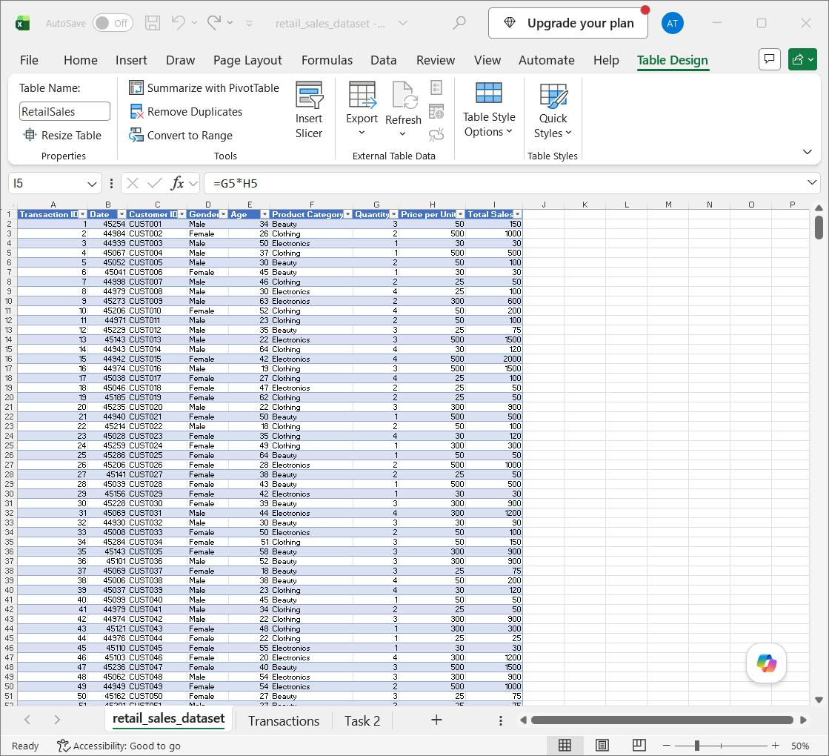  In order to format the data set into a table, I used control, shift and the down arrow to gather all the data in column A. To then gather the rest of the data, I used control, shift and the right arrow. Once the data was highlighted, using control and T, it formatted into a table. I then went to Data and named the table Retail Sales.
Print screen 2 | 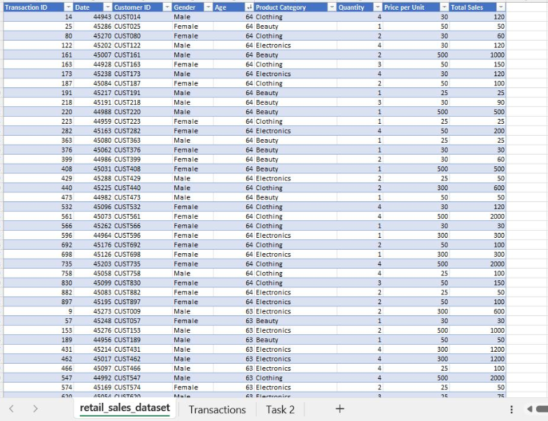  Secondly, to filter the ages I highlighted the age column and opened the drop down menu. Then I filtered the age from largest to smallest.
Print screen 3 | 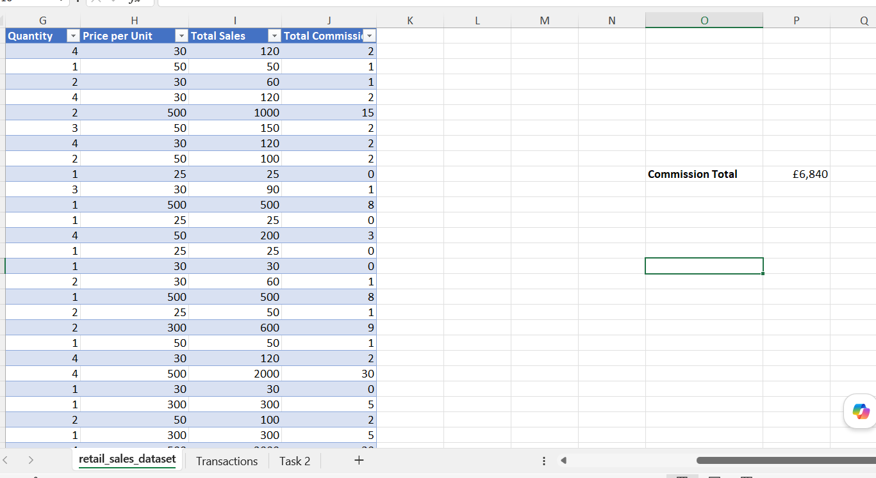  To get the commission total, I first needed to add a ‘Total Commission’ column. To create this column I based the commission off 1.5%. The formula I used for this column was =[@Total Sales]]*0.015. Once the column was populated, I converted the value into numbers and removed decimal points to keep the data and table tidy. In cell O10 I gave the name ‘Commission Total’ and in P10 I used the sum function. The formula I used was =SUM(J1:J1001) to get the final value.
Print screen 4 | 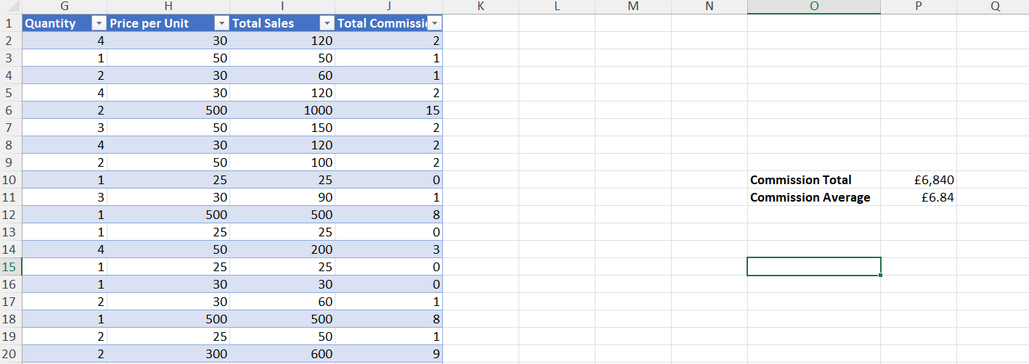  To get the average commission for our data set I used the average function. The formula inputted to P11 was =AVERAGE(J1:J1001). I then converted the value to currency to make the figure more understandable.

Day 2: Task 2

Please research and complete the following tasks within the document, and paste print screens into the provided box below:

Use the Student grades table provided by the tutor,

Convert the table to an Excel table. (Ctrl +T)

Student name | English | Mathematics | Science | Average | Highest score
Carol | 75 | 85 | 85
Khan | 85 | 75 | 80
Harry | 80 | 70 | 80
Sarah | 80 | 70 | 80
John | 65 | 80 | 70
Linda | 90 | 50 | 70
Edward | 55 | 80 | 60
Mary | 55 | 70 | 65
Thomas | 55 | 30 | 65

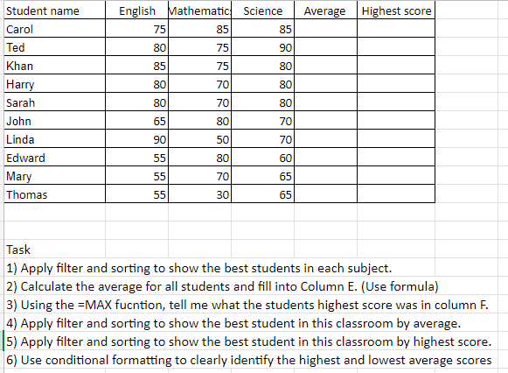

Print screen 1 | 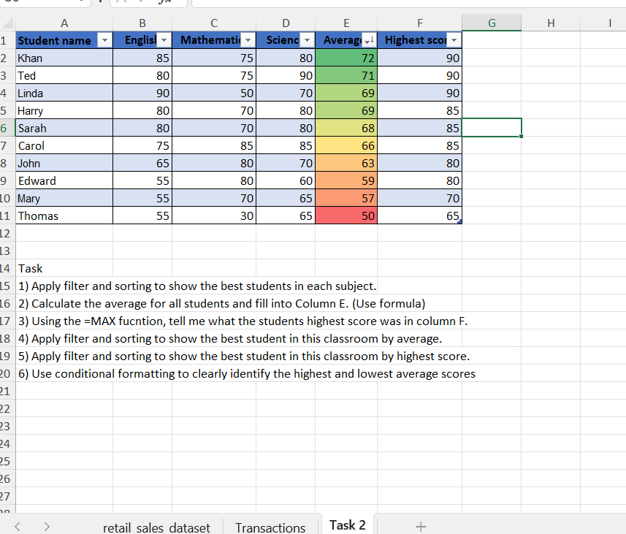  Firstly to create this table I used the data set and CTRL+SHIFT and down to gather column A data. Then using CTRL+ SHIFT and the right arrow to include the rest of the data up to column F. After formatting the data into a table and naming ‘Student_Scores’, using sort and filter this added drop down menus to each section. Each subject's highest score can be used by using the drop down on each column.  Secondly, I calculated the average for all students. The formula used was =AVERAGE(B2;D11). I then used the sort and filtering to display the best student in the class by average, followed by the highest score.  Finally I used conditional formatting to clearly highlight the scores from highest to lowest. This was added by selecting the ‘Average Score’ column and selecting conditional formatting on the home. The colour scales give a visual representation of the overall scores.

Day 2: Task 3

Using the skills developed today, have some fun with the data set you have imported. Paste your work below and enjoy!

Print screen 1 | 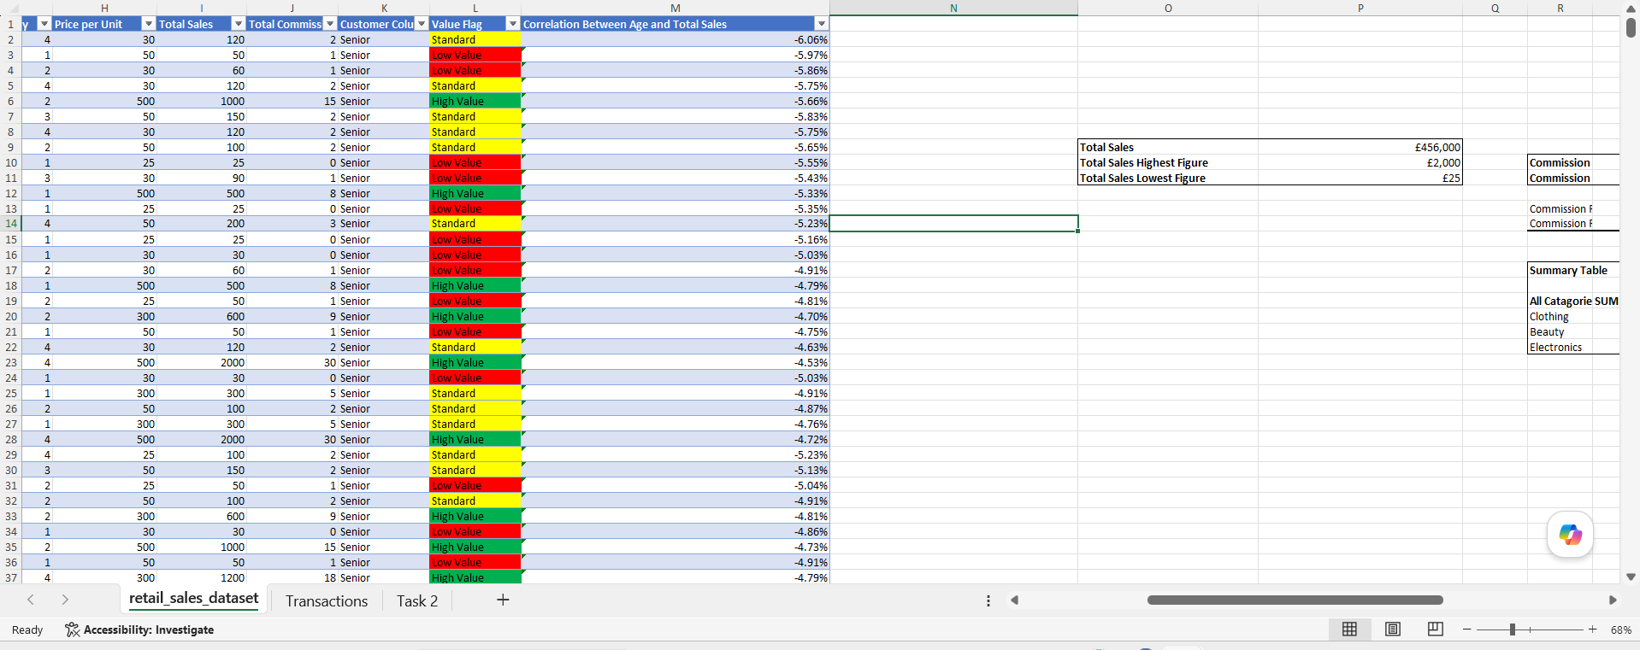  Using the skills I gained today, I also used additional methods discovered during my research. The first method I used was value flagging, which works by using IF statements to categorise cell values. To create this, the formula I used was ‘=IF(I2>=500,"High Value",IF(I2>=100,"Standard","Low Value"))’. This then enabled me to classify sales amounts depending on high, standard and low value. To apply a visual interpretation, I created and applied conditional formatting.  Another method I used from my research was correlation analysis. This method compares two values from categories to look for a relationship. In this data set I wanted to analyse the influence of ‘Age’ on ‘Total Sales’ with the CORREL function. To do this I used the formula ‘=CORREL(E2:E1001, I2:I1001)’. The values the formula outputted were small negative percentages. This highlights a weak relationship between ‘Age’ and ‘Total Sales’ within this dataset.

Day 3: Task 1

Dataset: Day_3_Task_1_Bike_Sales_Pivot_Lab.xlsx. and,
Lab instructions: Lab pivot table use for task 1 instructions

Make a copy of the dataset. Use the copy.

Convert to Excel Table (Ctrl +T)

Follow the lab instructions. Do not worry if you do not complete the lab; just working with data and playing with the pivot table will be a good experience.

Note:
Under refine the pivot table:
To mask 0's.
Click the pivot table
Click the Pivot Table Analyse tab on the menu bar.
Options > options > layout and format> In the field for empty cells, select the checkbox and enter 0 (zero). Ok.

And for the reflection questions, please do them in your workbook, not in the lab. 😊

Please paste your final pivot table below and complete the reflection questions:

Print screen 1 | 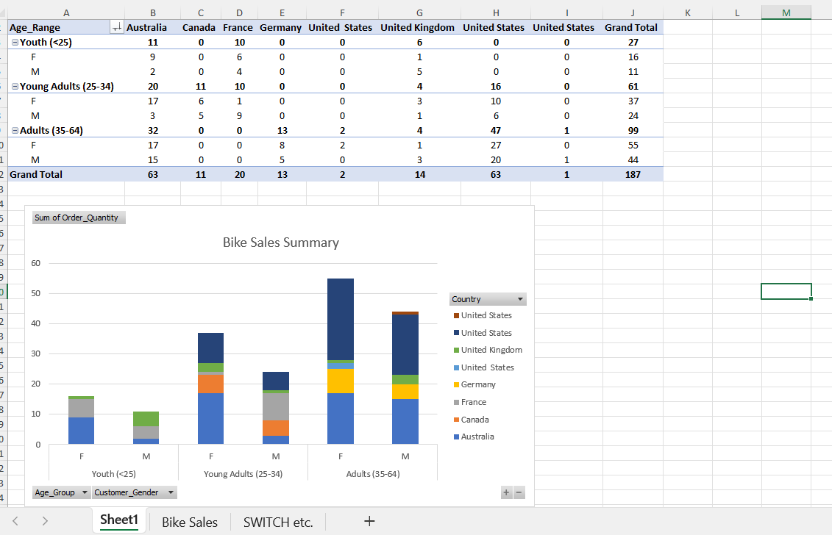
In which markets does Germany have customers? | 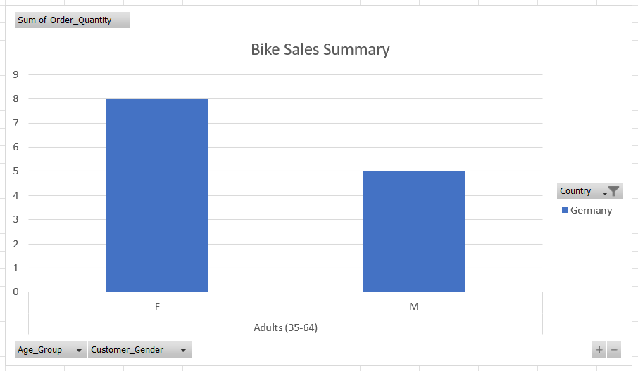Based upon the findings discovered through analysis, the market for bikes sales in Germany 2021, were adults ranging from 35 to 64. Within this market, adult females were the majority of sales, followed by adult men.
What country has sales in all markets? | 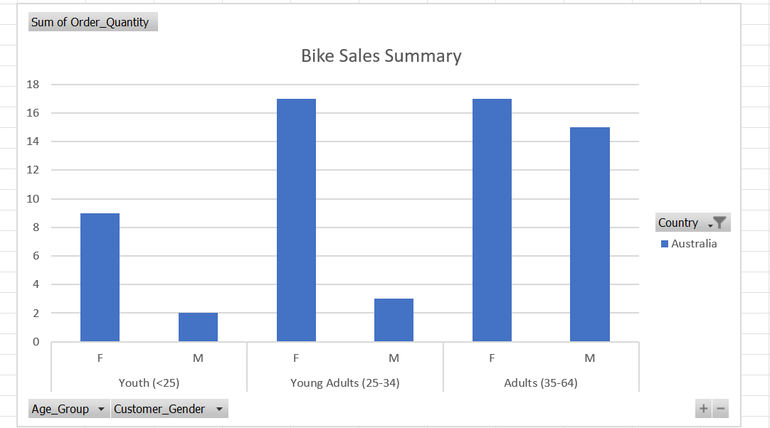  Based upon the findings from the summary pivot table and chat, Australia is the country that has sales across all markets. The market is covered by all age ranges, with a majority for adults, closely followed by young adults. In relation to gender sales, the sales market is predominantly females, with more popularity with adult men.
What are the most profitable markets by country, age group, and gender? | Using the findings from the sales summary, the most profitable for bike sales overall was Australia. In relation to age group, the majority market were the adult category, ranging from 35 to 64, with youth being the least. Referring back to the available data, the majority market across gender category were females.
Any other findings? | Upon collecting and cleaning the bike sales data set, I noticed there was only data available for the month of December in 2021. Therefore, the findings presented in the pivot table and the sales summary are solely based on that. If there was extra data available, for example all months through the year, or December sales in previous years. This would allow for a deeper analysis and provide for data to highlight trends in overall bike sales.

Day 3: Task 2

The dataset below tracks the sales performance of different products in various counties in England. Please paste the dataset into a blank Excel workbook. Your task is to:
- Create a Pivot Table to summarise the data by county and product.
- Use the SWITCH function to categorise products based on their sales volume.
See instructions below.

The dataset can be found in the last workbook you used.

County | Product | Sales Volume
Yorkshire | Laptops | 500
Yorkshire | Smartphones | 200
Cornwall | Laptops | 700
Cornwall | Printers | 400
Lancashire | Smartphones | 150
Lancashire | Laptops | 600
Essex | Printers | 800
Essex | Smartphones | 300
Durham | Laptops | 250
Durham | Printers | 300
Greater Manchester | Smartphones | 600
Greater Manchester | Laptops | 400

Dataset:

Step 1: Create a Pivot Table
- Select the dataset (columns A to C).
- Insert a Pivot Table to summarise the data by County in the rows and Products in the columns. Use Sales Volume as the value to be summarised.

Step 2: Use the SWITCH Function
In a new column next to your data, use the SWITCH function to categorise products based on Sales Volume as follows:
For sales greater than 600: "High"
For sales between 300 and 600: "Medium"
For sales less than 300: "Low"

SWITCH Function Example:
=SWITCH(TRUE, C2 > 600, "High", C2 >= 300, "Medium", "Low")

- Apply this formula to each row, and check if the products are categorised correctly.
- In ‘Sales Volume’, you need to remove the space after each amount – hidden spaces
- Confirm the data type is numerical

Submission:
- A completed Pivot Table summarising sales by county and product.
- A new column in the dataset categorising products by sales volume using the SWITCH function.
  - Please paste your completed work below

Print screen 1 | 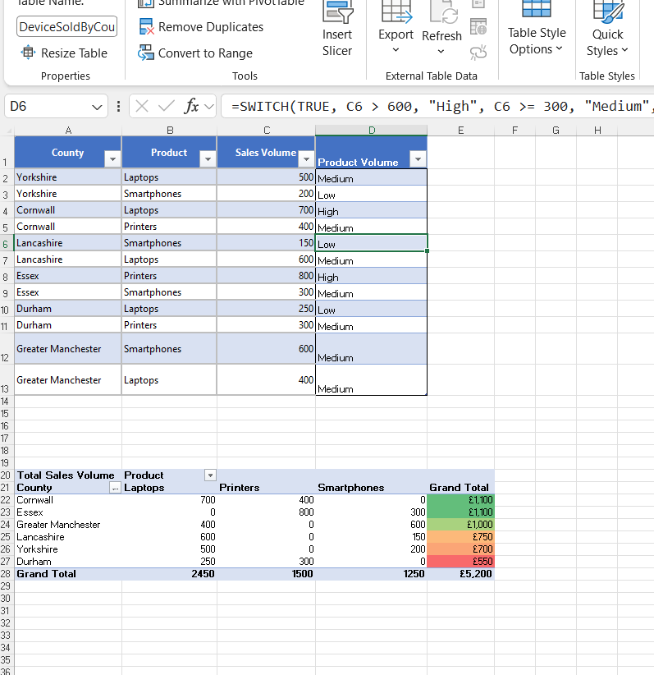  To create a pivot table from the data set, the data was first converted into a structured table using control and T. The table was named ‘Devices Sold By County’. Secondly, using and selecting the table, opening the insert tab followed by the tables drop down a pivot table was added to the existing page. This provided a summary table based on products sold per county. The use of conditional formatting and applying the sort function from highest to lowest provides visual representation of product performance per county.

Day 3: Task 3

Please download the dataset ‘Day_3_Task_3_Bike_Sales_Visualisations_Lab.xlsx’.
Also, download the lab instructions.

Pivot tables are already created; you will need to create the pivot charts.

Follow the lab instructions.

Do not worry if you do not complete the lab; just working with data and playing with the charts will be a good experience.

Please paste your results below:

Print screen 1 | 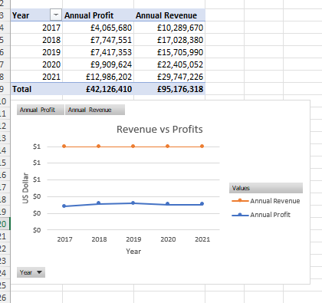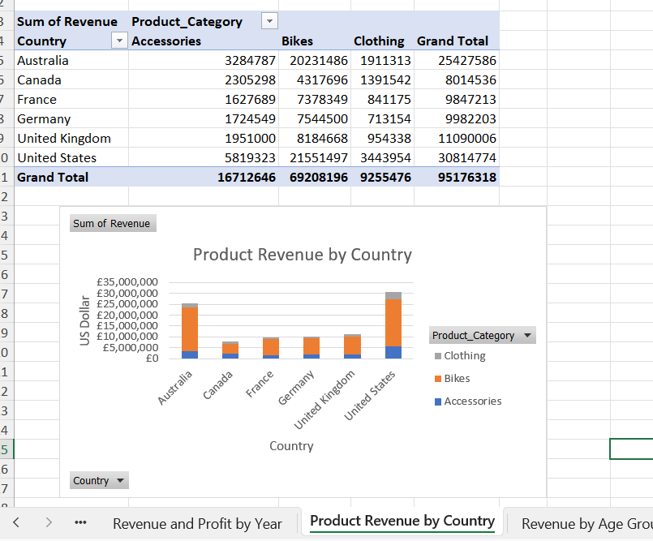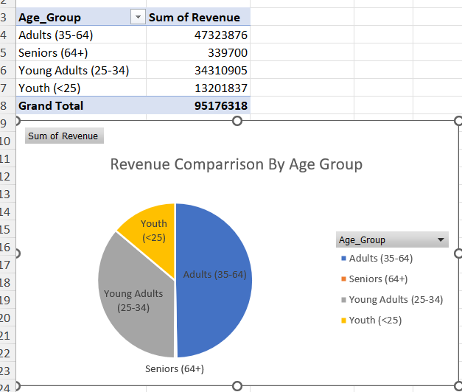

Day 4: Task 1

You have been asked to deliver your analysis findings to the board of directors. Within your analysis, you have identified that customers are leaving your company at the 12-month point, which is typically when they receive their renewal price.

Choose a business or organisation to focus your findings on.

Conduct research and complete the following questions:

As in all work situations, you can use AI Gen tools for research: it needs to be in British English, check spelling, grammar and maths; and written in your voice, not copied directly from the tool.

How would you prepare for the delivery? | To deliver analysis findings to the board of directors for British Gas, the first step taken would be to review and understand the data. With this data, I would perform analysis to identify trends, to explain the cause of customers leaving. I would collate the data into pivot tables and charts to make the data visually understandable with appropriate data.
What tools would you use for the delivery? | To deliver my analysis findings there are several tools to use for delivery. Initially, the data would be cleaned and analysed in the organisation's preferred software. In this scenario, I would prepare my data in excel, using encryption to keep the data secure. Once the data have been summaries to pivot tables, charts can be created which are more presentable. These charts can be inputted into a powerpoint for the presentation, which may be on team or in person.
What is prospecting, and why would you complete this before your delivery? | Prospecting is a method where you gather information regarding the organisation you are delivering your findings to. In terms of delivering my findings to British Gas, I would research the company to include their branding colours into my presentation to make it more relatable. This would be completed before delivering findings to tailor delivery of findings.  https://www.kanbox.io/blog/what-is-prospecting
Tell me the best practices for public speaking and providing updates to senior leaders | When speaking publicly, it is essential to present yourself using open body language and confidence using language suitable for the audience. When presenting updates to senior leaders, such as the board of directors, information should be accurate and concise focusing on relevant topics.  https://www.duarte.com/blog/how-to-effectively-present-to-senior-executives/
What will you show the board in your delivery? | Within my delivery to the board of directors at British Gas, I would provide a clear summary of my findings. The presentation would focus on why customers are leaving at the 12 month annual renewal point. I would highlight patterns identified within the data with common identified reasons for leaving, including increased tariff prices. For the presentation, the pivot table charts would be included in powerpoints to improve readability and comprehension of the data findings. Finally, I would suggest improvements to prevent the organisation losing business.
How will you articulate the changes that are needed? | To explain the changes required I would link the data analysis to actions that would reduce customers leaving. This involves explaining reasons why customers are leaving, such as higher prices. I would relate this information to customer satisfaction rates and customer retention. I would express the information in a clear and transparent way focusing on making improvements.
Provide a list of online resources and videos that will support your preparation for public speaking | https://youtu.be/-FOCpMAww28?si=hXx2oJeWisehM8zO
Evaluate tools that provide visualisation.  Tell me what they are.  Tell me what you would choose when delivering your presentation and why | The main tool used to provide visualisation would be Excel. From the data set I can create pivot tables and produce summary charts including bar charts and pie charts. Creating charts helps to make the data more accessible, enabling the audience to identify findings quickly and interpret the value.

Course Notes

It is recommended to take notes from the course, use the space below to do so.

Additional Information

We have included a range of additional links to further resources and information that you may find useful, these can be found within your revision guide.

END OF WORKBOOK

Please check through your work thoroughly before submitting and update the table of contents if required.

Please send your completed work booklet to your trainer.

